SmartPlant 3D Isometrics
ISOGEN Administrator Training

Table of Contents

Table of Contents i
LAB-1: Out of the Box Iso Extraction 1
LAB-2: Setup Custom Style 4
LAB-3: Setup Custom Border and Title Block 9
LAB-4: Setup Title Block Labels 12
LAB-5: Materials List 16
LAB-6: Dotted Symbology 17
LAB-7: Labels 19
LAB-8: Dimensions and Coordinates 23
LAB-9: Detail Sketch 25
LAB-10: Symbol Mapping 27
LAB-11: Custom Symbology 29
LAB-12: Change Management 31
LAB-13: Iso Break Control Points 33
LAB-14: Iso Control Content 35
LAB-15: Iso Weld Numbers Control 37

LAB-1: Out of the Box Iso Extraction

Objective: Learn to extract a pipeline isometric using standard delivered formats and options
Skip this section if you already had the user level training

- Enter SmartPlant 3D and switch to Drawings and Reports task 
- Right click on plant SP3DTrain, select New... to create a Folder
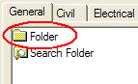
- Rename the new folder to: ISOS
- Right click on ISOS, select New... to create a Drawing By Query Manager from the General tab and OK
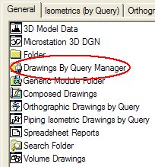
- Rename the resulting Drawing By Query Manager folder to Unit01
- Right click Unit01 and select Setup…
- Under Filter select More... and pick Training Filters>U01
- Under Packages Select More... and pick Iso Pipeline then OK
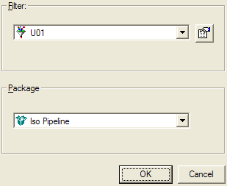
- Right click Unit01 and select Run Query
- Expand the tree structure just created under Unit01, right click Iso Pipeline and launch Create Drawings
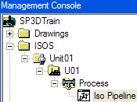
- Right click iso 1001-P and select Update Now
- Once the green check appears, right click drawing 1001-P and select Edit to review contents. Exit when done reviewing the drawing.
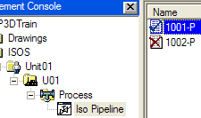
- Right click drawing 1001-P and select View Extraction Data
- Review log, pcf and isosheet drawing files
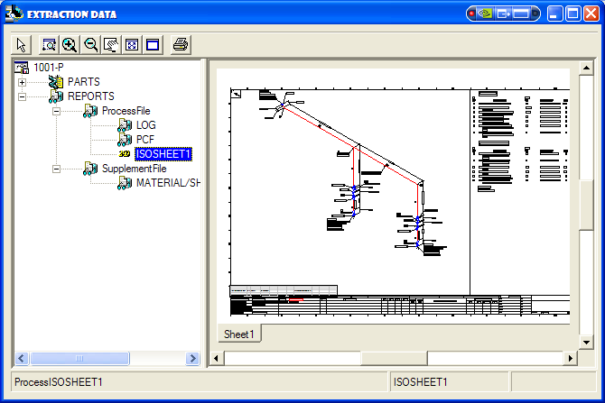

LAB-2: Setup Custom Style

Objective: To create a customized isometric drawing style for size D drawings
Part 1. Define border and options set
- Create an iso folder on your local machine to store the files to be copied, i.e. C:\IsoAdmin. In practice however custom files must be kept in the server.
- Copy the file Iso_Pipeline.igr from \\[SP3DServer]\Symbols\PmfgIsoStyleData
Instructor or CAE will provide the name of the SP3D server
- Copy the file Iso_Pipeline.XML from \\[SP3DServer]\Symbols\ PmfgIsoStyleData
- Rename the copy ShawIso_Pipeline.XML
- Uncheck the read only property for the files
- Open the ShawIso_Pipeline.XML file using a text editor and use the search/replace tool to change all occurrences of Iso_Pipeline to ShawIso_Pipeline
Note: If you are a former PDS iso admin, browse the contents of this XML file and see if it looks familiar.
- Save and exit the file

Part 2. Bulkload Style

- Copy the file Bulkloadisokeys.xls from C:\Program Files\SmartPlant\3D\ CatalogData\BulkLoad\DataFiles to C:\IsoAdmin
- Make sure the file is not read-only
- Open Bulkloadisokeys.xls>PipeMfgRules worksheet
- Select row 6 (Iso_Pipeline) and right-mouse>Copy
- Right-mouse>Insert Copied Cells into the next row
- Insert a letter ‘A’ (Add) in the first column of row 6
- Change Iso_Pipeline to ShawIso_Pipeline in the IsoNames column
- Change OutPutIsoDrawingsLocation to IsoDrawings\ShawIso_Pipeline
- Change IsoBackingSheet to PmfgIsoStyleData\ShawIso_Pipeline.igr
- Change IngrOption to PmfgIsoStyleData\ShawIso_Pipeline.xml
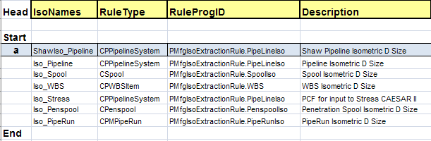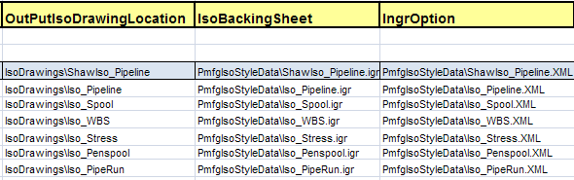
- Save the spreadsheet and close Excel
- In the Symbols share for your training plant (provided by instructor or CAE) open folder PmfgIsoStyleData. For example: \\Servername\Symbols\PmfgIsoStyleData
- From C:\IsoAdmin copy ShawIso_Pipeline.sha and ShawIso_Pipeline.XML into \\Servername\Symbols\PmfgIsoStyleData
- Notice these are the files pointed to in the IsoBackingSheet and IngrOption values
- Start the Bulkload utility using Start à Programs à Intergraph SmartPlant 3D à Database Tools à Bulkload Reference Data
- Click the Add button and add the BulkloadIsoKeys.xls from C:\IsoAdmin
- Change the bulkload mode to Add/Modify/Delete records
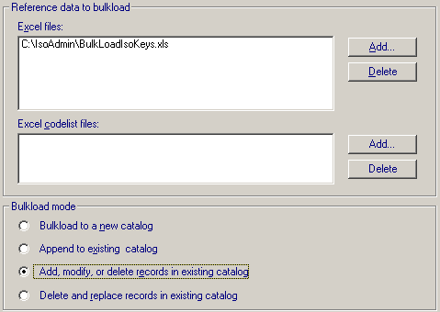
- Pick the database server name, catalog and catalog schema database names for the training plant (to be provided by instructor or CAE)
- In the log file field, select the ellipsis (…) button and click OK on the dialog
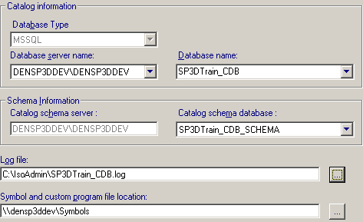
- Click Load to load the new style into the catalog
- After bulkload completes, review the log file to make sure there are no errors
Part 3. Define and use style package

- After bulkload, open SP3D training plant, and go to Tasks>Drawings and Reports
- In Drawings and Reports task, add a new folder: Drawings\Isos\Packages
- Right-click on Packages folder and add a new Piping Isometric Drawings by Query component
- Rename the component ‘ShawIso_D’
- Right click ShawIso_D then Setup… and in the Filter field select More…
- Expand the tree to Catalog Filters >Default Filters >SP3D Object Filters >Object Types >Piping and pick Pipelines filter
- In the style field, select the style ‘ShawIso_Pipeline’
- Right click ShawIso_D and Save Package as ‘ShawIso_Pipeline_Pkg’ under Isometrics (By Query) tab
- Right click on Isos, select New.. to create a Drawing By Query Manager from the General tab
- Rename the resulting Drawing By Query Manager folder to Unit01_D
- Right click Unit01_D and select Setup..
- Under Filter select More.. then create a Plant filters folder for iso drawings (recall Common Apps training)
- Create a simple filter to locate the training plant’s Unit 1 (Area2>U01>Process)
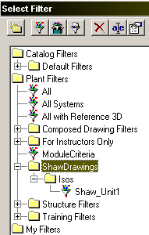
- Select your new filter and OK
- Under Packages Select More.. and pick ShawIso_Pipeline_Pkg, then OK
- Right click Unit01_D and select Run Query
- Expand the tree structure created, right click ShawIso_D and launch Create Drawings
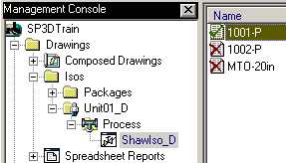
- Right click iso 1001-P and select Update Now
- Once the green check appears, right click drawing 1001-P, and pick Edit (a double click will also work ok to open it in review-only mode)
- The drawing looks just like it did when extracted using out of the box Iso Pipeline options. In the following section, the output will be customized for C size extractions
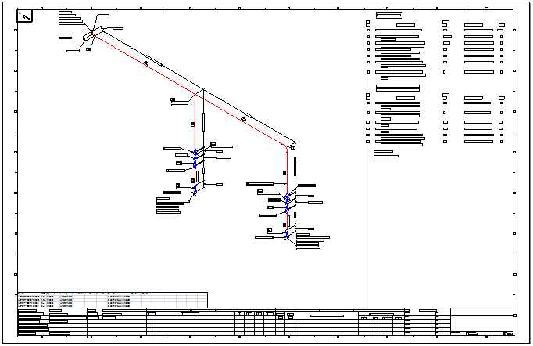

LAB-3: Setup Custom Border and Title Block

Objective: To create a Shaw is style with customized border and title block

- Right click Unit01_D\Process\ShawIso_D and select Edit Options…
Note: This will open the style options browser where options switches are controlled from
- Expand Drawing.Controls
- Change DrawingSize and PostScriptSize to ANSI “C”
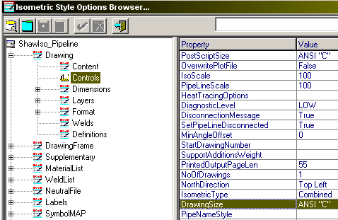
- Save and exit the options browser
- Update Unit01_D’s drawing 1001-P. A C-size multisheet drawing is created
- Right-click 1001-P to Save-As 1001-P.sha file to folder C:\IsoAdmin (Later to be copied to \\<server>\Symbols\PmfgIsoStyleData\)
- Open 1001-P.sha and use File >Sheet Setup, set size to C-Wide
- Use View >Background Sheets to edit the border and title block
- Use File >Sheet Setup, to set Background size to C-Wide
- Use the iso and MTO graphics as reference to draw a simple C-size border, or paste it from another source from a Shaw standard border. Feel free to add a logo etc but don’t attempt to create your corporate border at this time. For this example, the MTO area from the D size iso was maintained, but it too can be adjusted
Hint: Shape2d application can open Microstation and Autocad files
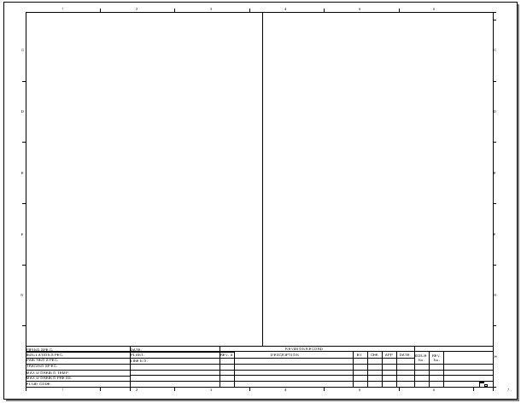
- Once the border and title block have been fitted to the C-size sheet, remove any other sheets besides Backing and Sheet 1, as well as the iso graphics from 1001-P
Create the new C style
- Rename the 1001-P.sha file to ShawIso_C.igr
- From \\<server>\Symbols\PmfgIsoStyleData\ Copy ShawIso_Pipeline.XML to C:\IsoAdmin\ShawIso_C.XML (DO NOT copy the one from inside IsoAdmin folder, it’s the wrong size!)
- Open the ShawIso_C.XML file using a text editor and use the search/replace tool to change all occurrences of ShawIso_Pipeline to ShawIso_C
- Copy ShawIso_C.igr and ShawIso_C.XML to symbol share in \\<server>\Symbols\PmfgIsoStyleData\
- Open Excel file BulkLoadIsoKeys.xls in C:\IsoAdmin
- Copy line 6 and insert it in, edit all values to reflect ShawIso_C
- Place an A in the first row for Add by bulkload, save and exit
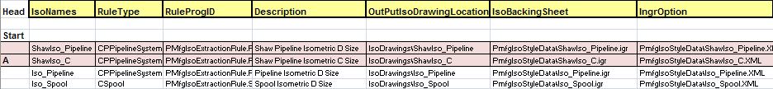
- Use Bulkload utility to reload BulkLoadIsoKeys.xls as it was done for lab 2
- Repeat the steps from lab 2 part 3 above to define a style package that will use the new C size template, and extract the C iso for line 1001-P
Note: Use names reflecting C isos this time where applicable. For example, in step 7, use the style ShawIso_C; in step 8 use something like ShawIsoC_Pkg; in step 10 use Unit01_C for the name, and so forth.
- Review the C iso output.
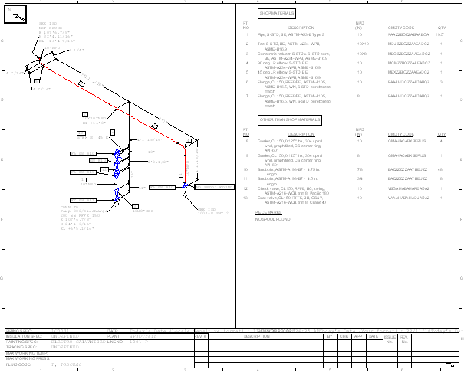
- To fine tune your output, right click ShawIso_C, and select Edit Options…
FYI: the date format will be fixed in the next lab
- In the labs that follow, you will go back to working with the D size isos style and format

LAB-4: Setup Title Block Labels

Objective: To map attribute labels to the title block

- Edit Options for the Iso Pipeline style in Unit01_D by right-clicking on ShawIso_D and selecting Edit Options…
- First, set the drawing size from C back to D. In the look-up box, enter the word “size” and Enter. All switches with the word “size” in them will appear, including the two that we need to set back to “D”
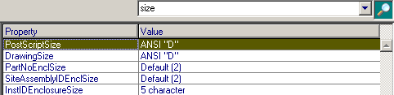
- Next, expand AttributeMAP and add a new row by clicking on the first attributes row, followed by
- Name the new HostAttribute User1, pick ATTRIBUTE21 for the Isogen Attribute and pick the origin as ‘User’
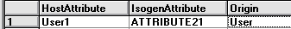
- Expand Labels.DrawingFrame and add a new row
- Pick ATTRIBUTE21 for label attribute
- Pick the catalog label: Types of labels>Piping>Tooltips>Piping Tooltip Pipe Line as the LabelName
- Pick PipeLine as the OidType
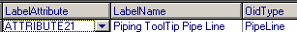
- Expand DrawingFrame.Attributes and add a new row
- Pick User1 for HostAttribute and specify values as below
- Save to catalog
- Update isometric for the pipeline 1001-P in Unit01
- Review the new tooltip-style line label, repeat step 9 above as needed to reposition the label in the title block
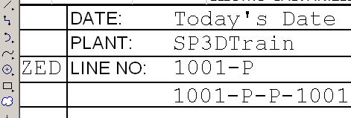

Changing the date label
Notice in the illustration that the date value is not getting passed to the label. Repair the label and make it show a European format
- Right click ShawIso_D and select Edit Options…
- Select AttributeMAP and locate the IsogenAttribute holding the “Extraction Date”
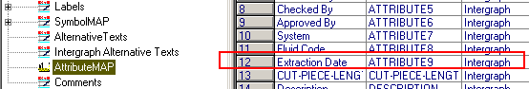

- Go to Labels>DrawingFrame
- Next to ATTRIBUTE9 select the LabelName field
- Select Types of Labels>Piping
- Locate and select the label format for European date, OK
- Save and exit
- Update 1001-P and review the date field
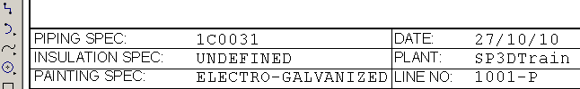

Line List View
An Excel LINES LIST table containing the properties of the pipe runs in the pipeline may be placed on the iso at the desired coordinates. We don’t currently use this at Shaw, but this lab will teach you how you might embed an Excel report into iso drawings should the need arise in the future.
Make sure Trust Access to VB is enabled under Excel Office Button>Excel Options >Trust Center> Trust Center Settings>Macro Settings>Trust access to VBA…

- Edit options for ShawIso_D
- Set DrawingFrame.PipeLineList.ShowPipeLilneListBox = True
- Set DrawingFrame.PipeLineList.UseReportTemplate = True
- Verify additional parameters are as shown:
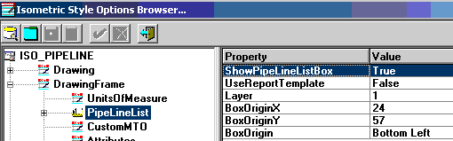
- For the option DrawingFrame.PipeLineList.ReportTemplate.TemplateName, pick the ellipsis (…) and select the catalog report template from Reports – Types of Reports – Piping – Piping Pipelines Sorted by Name
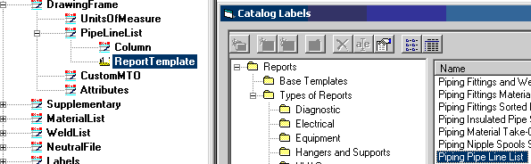
- Save options and extract line 1001-P to review the new line list
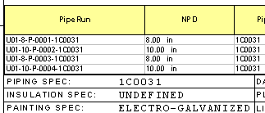

Turning off the Excel line list view
- Return settings to UseReportTemplate = False and ShowPipeLilneListBox =False, save and Exit. This will eliminate this report from the iso drawing space
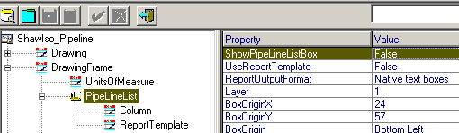

- Update-Now 1001-P and verify that the lines report is gone from the drawing area

LAB-5: Materials List

Several options exist for formatting the material list. In addition to modifying the standard (fixed) material list, it is also possible to use a variable or user-defined material list, where the attributes and their order are specified by the user. It is also possible to use labels to define attributes.
Objective: To customize the materials list side of the iso drawing using the Variable Layout options

- Edit Options for the ShawIso_D style
- Expand MaterialList.VariableLayout.Column
- Fill in values as follows:
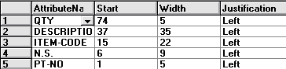
- Set MaterialList.VariableLayout.TextSize to Medium
- Set MaterialList.ActiveList to Variable
- Update isometric for line 1001-P in Unit01 and review the materials list
Note: Notice the headings are out of alignment
- Adjust the heading as needed in MaterialList.VariableLayout.HeaderLines so that headings align with the materials list columns
Hint: | = End of Line; / = New Line.
- Update line 1001-P and review your materials list. A couple extra interactions may be needed to fine-tune the headings’ positions

LAB-6: Dotted Symbology

Objective: To learn to manipulate the display of elements based on their part attributes

- Edit Options for the ShawIso_D style
- Select Drawing.Format.DottedSymbologyEnable = True
- Select the ellipsis (…) in the Drawing.Format.DottedSymbology.DottedDimensionedFilter field to invoke the Select Filter dialog
- Expand Catalog Filters\Default Filters and create a new folder under SP3D Drawing Filters named “Isometric Drawing Formatting”
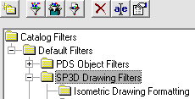
- In the new folder, create a new filter and name the filter ‘Dotted Dimensioned Parts’
- On the Object Type tab, select Piping\Piping Parts
- On the Properties tab, click the Property pull down menu and select More..
- In the Select Properties dialog, select the Construction Requirement property as shown
- Back on the Properties tab, select the operator “=” and set Value to “Existing” from the list
- Click OK to create the new filter, open filter folder “Isometric Drawing Formatting”, and then select the filter “Dotted Dimensioned Parts” for the style
- Save the options data to catalog
- Switch to Piping task, select a few piping parts from the line 1001-P and change their construction requirement to Existing
- Update drawing for 1001-P and review Existing parts on the iso
Notice that the existing parts still get dimensioned
- To turn off iso drawing dimensions on existing piping items, return to editing the Options for style ShawIso_D
- In Drawing.Format.DottedSymbology change the Value entries by cutting the filter value previously set and pasting it in the field for DottedUnDimensionedFilter
- Save the options and update line 1001-P
- Review the resulting iso, the dotted piping components should not show any dimensions
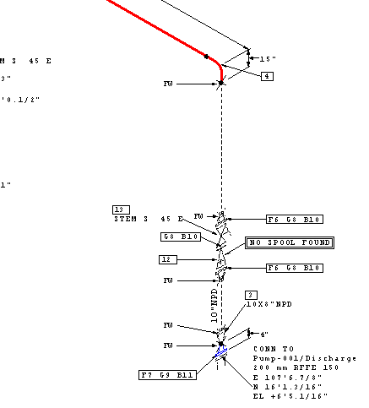

LAB-7: Labels

Labels are used extensively in SP3D Isometric Drawings. They may be used to output a note on the drawing, determine where an attribute break should occur, gather data for stress analysis etc.
Objective: To learn the use of customized labels
- Edit Options for the ShawIso_D style
- expand the tree to find Labels.ComponentNote and then click the green check to insert a row
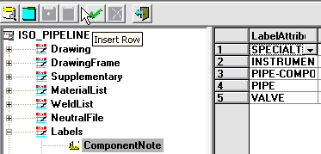
- In the LabelAttribute2 column, select VALVE, then in the label column, browse to the catalog for the Catalog Labels and pick the Piping> Piping Isometric Valve Tag label
- In the message enclosure column, pick MESSAGE-SQUARE
- Save to catalog and update line 1001-P. You should see the valve tags shown on the iso next to the valves
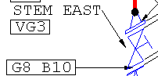

ATTRIBUTE BREAK
This functionality has two parts: Setting an AlternativeText and supplying a label to get the data for parts.

- Edit Options for the ShawIso_D style
- Expand AlternativeTexts and scroll down to ATEXT, notice that the value for -289 is set to “CLASS” for piping spec breaks
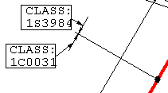
- Replace “CLASS” with “SPEC” and save
- In piping task, add a piping spec break at a joint on line 1001-P
- Update iso of line 1001-P. Spec break should resemble this
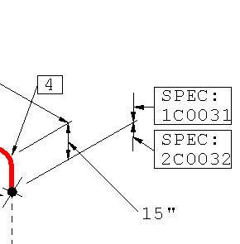
The standard attributes are piping specification, insulation specification, tracing specification and painting specification. Whether the breaks are shown on the iso is actually controlled by the Alternative TEXT values being set or not for each attribute. If the ATEXT value is set to a non-null string, the string is output as a prefix.
Miscellaneous or user-defined break attributes are set using labels.

MISC. ATTRIBUTE BREAK (failing with SP3D V2009.1 at time of last testing)
- Edit Options for the ShawIso_D style
- Expand the tree to find Labels.MiscSpec and set MISC-SPEC3 to:
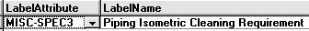
- The ATEXT corresponding to MISC-SPEC3 is numbered -295. Expand AlternativeTexts and notice that the value for this ATEXT is set to “CLEAN:”
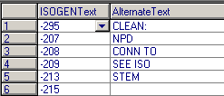
- Leave values unchanged. Switch to Piping task, select a pipe run on 1001-P and set its Cleaning Requirement to ‘CC1’ (Under “Surface Treatment and Coating” Category)
- Switch back to Drawings and Reports task and update drawing for line 1001-P. Cleaning requirements breaks show as below
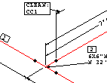

CONDITIONAL LABELS
Sometimes it is desired to output a note on the isometric based on certain criteria. E.g. tags for valves with certain attribute are to be output on the iso but for other valves nothing is to be ouput.
- Edit Options for the ShawIso_D style
- Expand the tree to Labels.ComponentNoteConditional
- Set the values for the VALVE label row as shown:
- Save to catalog and update drawing 1001-P. You will see that a tag is output for the check valves (VC3 in a box enclosure) but not for the other valves.
Note: The TestValue and the resulting output label value don’t have to be the same string
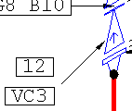

END CONNECTION
These are special labels that are evaluated for end connections of an isometric.
- Edit Options for the ShawIso_D style
- Select Labels.EndConnection to select an end label
- For evaluating the END-CONNECTION-EQUIPMENT label, the nozzle is passed to the label and the label is responsible for returning the data of interest such as equipment name, nozzle name, and nozzle attributes such as size, end preparation, pressure rating etc.
- For the END-CONNECTION-PIPELINE label, the piping part connected to the last object on the current iso line is passed to the label. It is the label which then retrieves the appropriate continuation item based on the kind of isometric being run
- Extract any iso with eqp or line continuation labels in it to test
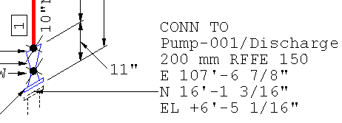

LAB-8: Dimensions and Coordinates

Objective: To edit the iso option switches to manipulate the display of dimension lines
- Edit Options for the ShawIso_D style
- Open the switches relating to dimensioning and coordinate outputs found under Drawing.Dimensions
- Set Dimensions.USAStyle to True
- Set Dimensions.ImperialFormat to Space Dash
- Set Dimensions.Overall to Across Branches
- Set Dimensions.ColumnReference.Enable to True
- Set Dimensions.ColumnReference.ReferenceLocation to Gridline
- Set Dimensions.ColumnReference.Enclosure to Diamond Ends
- Set Dimensions.ColumnReference.StrReferenceFilter to U01
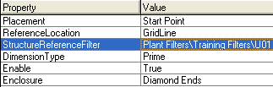
- Save settings and exit
- Update drawing for line 1001-P
- Open the drawing and review the drawing dimensions. Verify the above options.
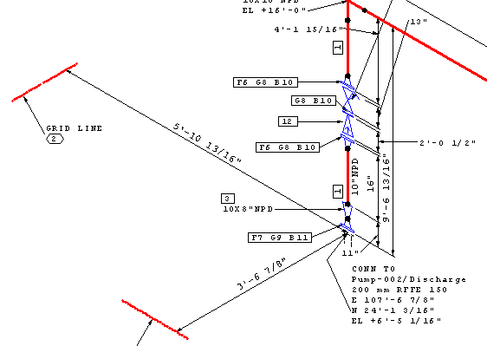

LAB-9: Detail Sketch

Functionality to show static detail sketches is available. Depending on the part class of the object selected, a specified label is invoked, if the value returned by the label matches the value specified to check against, the sketched symbol is shown on the isometric.
Objective: To cause the creation of a detail sketch on the iso anytime a predetermined hanger type is found on the line being extracted
- Open the 2D Editor from:
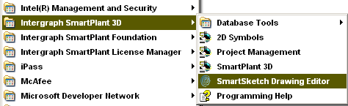
- Start rectangle tool and draw a 50mm x 50mm and angle 0 rectangle
- Using the Text command, place the word DETAIL using Courier New font with 2mm text size at coordinates (x=37mm, y=47mm) measured from the bottom left corner of the square
Hint: Use pinpoint and enter the units when typing coordinates if your default is in inches
- Draw your detail sketch graphics in the square: A pipe hanger
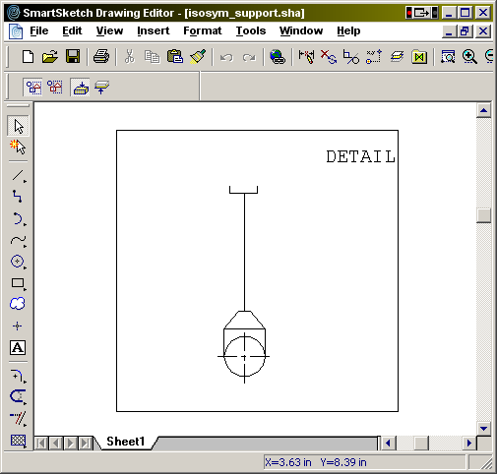
- Activate the selection tool and fence the box and its contents (hanger)
- While the detail box and contents are selected, create a new symbol using the Create Symbol command
- Place the origin of the symbol on the bottom left corner of the rectangle frame
- Save symbol to \\Server\Symbols\PmfgIsoStyleData folder with name DETAIL116.SYM. (Instructor or CAE will provide exact name of server)
- Exit Drawing Editor

- Edit Options for the ShawIso_D style
- Change Supplementary.DetailSketches.Path to be \\Server\Symbols\PmfgIsoStyleData\ ( with \ at the end)
- Set ShowDetailSketch to True
- Open Supplementary.DetailSketches.SketchMapping
- Change HANGER.SYM to DETAIL116.sym in row 2
Change SketchChkValue to Assy_VS_SR_DB_116 (this is the generic catalog part number, not an individual support’s tag name)
- Save to Catalog and exit
- Extract the iso for line 1002-P. A detail sketch for the hanger will be shown on the top right corner of the isometric
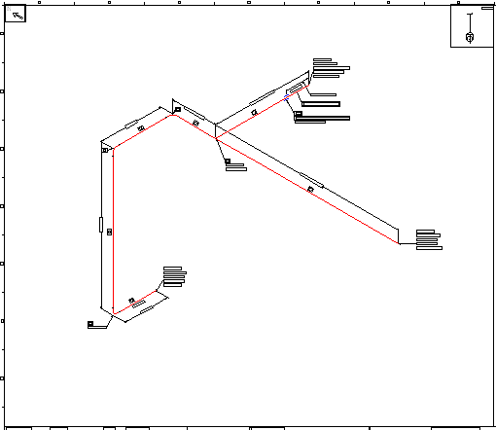

LAB-10: Symbol Mapping

It is possible to map part classes, supports, welds and end conditions to distinct Isogen symbol keys (SKEY). For part classes, it is possible to specify different symbols for different end conditions (“endpreps”). It is also possible to specify that the same SKEY should be output for all end conditions.
Objective: To learn the use of symbol keys mapping by replacing default SKEY values with alternate mappings from the symbol keys documentation
- Edit Options for the ShawIso_D style
- Select SymbolMAP and click the column heading “SP3DPartClass” to sort in ascending order (not the default)
- Scroll down to find part class item GateValve
- Open the SKEY document and look up the symbol key name for a gate valve. (C:\Program Files\Common Files\Intergraph\SmartPlant\Help\Symbol Keys.pdf)
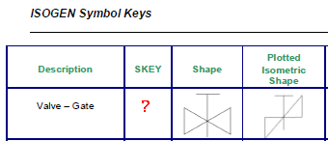
- Replace the generic valve symbol with the symbol for gate valve per the Symbol Keys documentation (pg. 86). Notice you could also select from the pull down list under the IsoGenSkey field
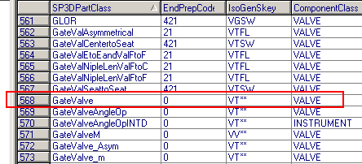
- Save to catalog and update drawing for line 1001-P
- Review the gate valves in the updated isometric

Note: It is possible to map individual end conditions (“endpreps”) to distinct Isogen symbol keys (SKEY).
- Edit Options for the ShawIso_D style
- Expand SymbolMAP.Supplement
- Change the EndPrepMap in the row that corresponds to EndPrepCode 21 (RFFE) to CL as shown:

- Save to catalog and update line 1001-P
- Notice changes at flanged valves, they are actually shown clamped
- Go back and change end prep mapping back to the original end SKEY (FL)

LAB-11: Custom Symbology

Functionality is available to re-define the symbol keys supplied with the Isogen software or create new symbol keys in addition to those supplied.
Objective: To replace the delivered gate valve iso SKEY symbol with a user defined iso symbol
- Install Alias Iso Utilities on your workstation (Contact CAE)
- Launch Iso Utils >Symbols.exe to start the Alias Symbols Editing program
- From the drop-down on the ribbon bar, select Redefining Valves
- Select Symbol >New. The Add New Symbol dialog will come up
- Place a check in the Copy Symbol From checkbox
- Click on the browse button next to the Old Symbol Key text box to bring up the Select Existing Symbol Dialog box
- From the dialog box, select the Basic Valve. The dialog will automatically be dismissed
- Enter the new symbol name: VU**
Note: To see what valve SKEY names have already been used, click the browse button for the old symbol key field, then use Cancel to dismiss it. Also, the SKEY documentation can be used to search for a symbol name across all items, not just valves.
- Select the browse button and select the 01SP spindle key (Even if it is the default value, select the browse button to see the different spindle options available)
- Keep the Scale Factor set to 100. It’s ok to experiment with other values
- Turn off the flow arrow
- Set Dimension and Orientation controls to the same as the old SKEY
- Select Create Symbol. This will take you to the graphics-editing environment with the current symbol displayed
- Select Move >Symbol Within Grid from the main menu.
- Click on the intersection of lines that is two units (blue lines) East and up anywhere near the top of the editor. The point you click becomes the new end 1 point for the symbol.
- Select Move >Start Point/End Point from the main menu to relocate points as show (green/red pts)
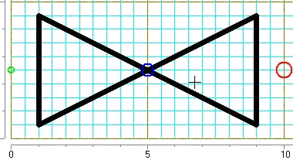
- Right-click the mouse anywhere on the grid to end a command.
- Click on the small green circle to being drawing a line. A stretch line will appear, another click of the mouse at another point will create a solid line. Continue the lines and complete as shown, or draw your own variation, keeping in mind that it must be symmetrical:
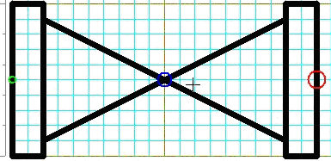
- Select the Done button on the left-hand vertical toolbar. This will save your edits to the symbol
- Select File >Save As from the main menu and save the symbol library file to:
[Symbols Share]\PmfgIsoStyleData\Symbol.asc (A Symbol.bin file is automatically created).
- Exit the symbols editor
- Edit Options for ShawIso_D style
- From the Options Browser, select Supplementary.DataFiles
- Click in the right-hand pane and press the Insert key on your keyboard to insert a row in the collection
- Select the dropdown in the DataFileType column and select ASCII-SYMBOLS
- Click on the browse button in the FilePath field and enter the full path to the symbols file
- Go to SymbolMap and look up SP3DPartClass “GateValve”
- Change the gate valve’s SKEY to VU** by typing it in
- Save your style edits to the catalog and exit the Options Browser
- Extract pipeline 1001-P and review the gate valves
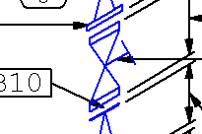

LAB-12: Change Management

Change Management on a piping isometric drawing refers to the fact that the same information needs to appear on the same sheet of an isometric drawing each time you extract the drawing.
Objective: To implement change management to facilitate control of single-sheet isos
- Edit Options for the style ShawIso_C created in Lab 3 above
- Set Drawing.Content.ChangeManagementEnabled option to True
- Set the Drawing.Controls.PipeLineSplitting option to 90 (%)
CAE Notes:
We have found that currently this switch is being ignored when Drawing.Content.ChangeManagementEnabled is set to True.
In order to take advantage of this feature in production, this value can be set to 110% when change management is set to False to decrease the likelihood of an iso being extracted on more than one sheet.
- To handle material list overflows from sheet to sheet without breaking change management, use isometric option settings:
  - MaterialList.MaterialListOverflow to Continuation Sheet
  - MaterialList.OverflowDrawingID to Alpha suffix (e.g: 2A, 3A, etc).
  - Set MaterialList.Drw1of1OnSingleIsos to True
- With all these things done, part items will remain on the same sheet if new revs are issued. However, perhaps due to a bug in the system, currently change management forces all items into a single sheet at almost any cost
- Extract any pipeline, i.e. line 1001-P, and review sheet content
- Switch to Piping task and model some new branches with components on line 1001-P. For this example several branches were added to push the limits (not required for student to do):
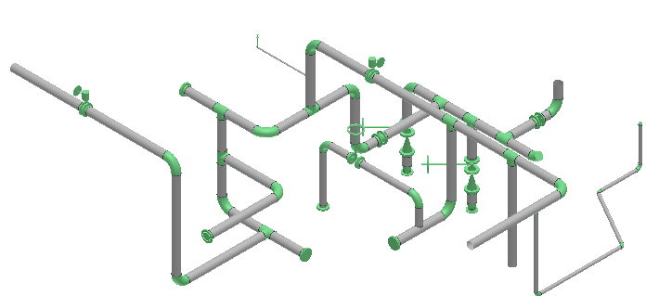
- Extract line 1001-P again and review the sheets’ contents
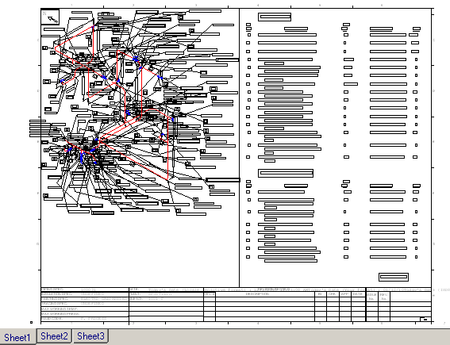
- Notice how Isogen attempts to keep all items in one sheet, with overflow sheets for the MTO when necessary (sheets 2 and 3 in the illustration)
- Edit Options for the style ShawIso_C
- Set Drawing.Content.ChangeManagementEnabled option to False
- Extract line 1001-P again and review the contents
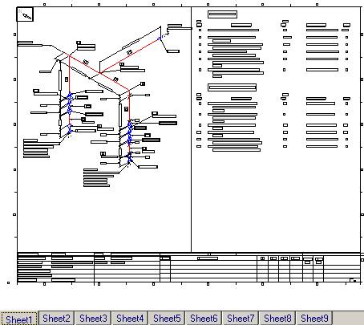
- A basic multi-sheet drawing is generated
- Return to the Piping task, set the locate tool to piperun, and delete the extra piperuns created for this lab

LAB-13: Iso Break Control Points

The system can force a new drawing sheet for a given pipeline or piperun extraction by inserting a PipingMFG Limit Point in the model.
Objective: To use control points as iso drawing limit points
- Edit Options for the ShawIso_D style make sure to turn off Change Management if it was activated for this style
- Extract iso of 1002-P, it should be one single sheet
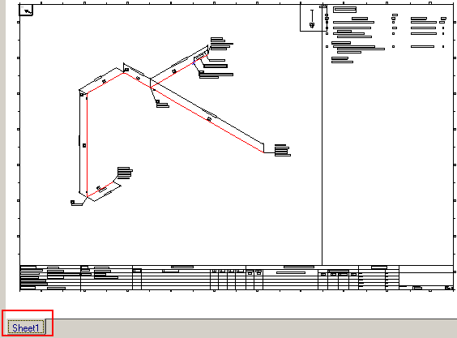
- Switch to Piping task and select Insert > Control Point
- Set the subtype for the control point to PipingMfg Limit Point and insert at a shop weld joint (or a Flange-Flange point when available). Make sure the parent of the control point is a Route Connection object rather than a weld or a part item
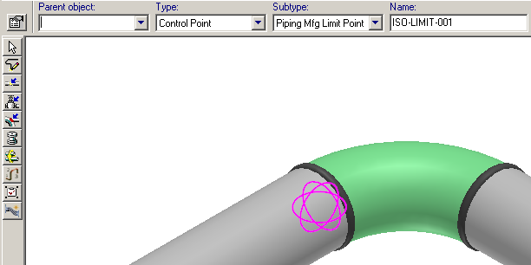
- Extract iso of 1002-P, the updated drawing should have two sheets
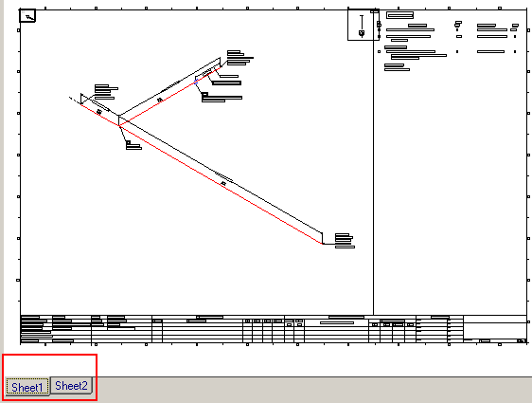
- The Piping Component File (PCF) should have the line ISO-SPLIT-POINT followed by the X, Y, and Z coordinates of the isometric break control point

LAB-14: Iso Control Content

The Drawings.Content.HonorSpoolAtBranch option allows you to drive the content for isometric drawings for pipelines according to spools.
Objective: To manipulate spooling to force stub-ins to be a part of the header’s iso
- In Piping task, create two new pipeline systems in unit U01: LINE_01 and LINE_02
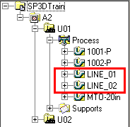
- Using piping spec 1C0031 model in space a 10in header pipeline system under LINE_01, then a 6in RWeld (default) branch as LINE_02 with a flange take down joint 12in from the header CL as shown
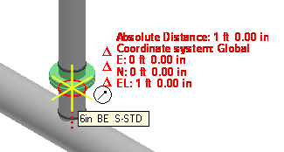
- Use the spools command to generate the spools with the Include Stub-Ins with Header Spool property set to True
- Switch to Drawings and Reports task and edit Options for the ShawIso_D style in Unit01, expand the tree to Drawing.Content.HonorSpoolAtBranch and set to True
- Switch to Drawings and Reports task and create iso drawing for LINE_01. It should include stub-in and flange despite their belonging to line system LINE_02

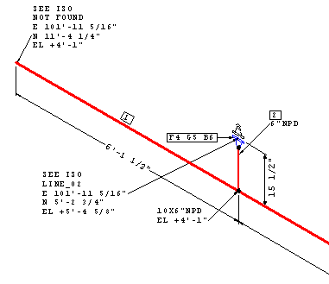

LAB-15: Iso Weld Numbers Control

Drawing.Welds.WeldNumberLabel Specifies a label to use with the weld number on the isometric drawing. There are two delivered weld number labels you can use with this option: Piping Isometric Weld Sequence Number and Piping isometric Weld Type and Sequence Number.
Objective: To activate and manipulate the display of welds on the iso
- In Piping task, use the Sequence Objects command to generate weld numbers for line 1002-P
- Switch to Drawings and Reports, Edit Options for style ShawIso_D
- Expand to Drawing.Welds.WeldNumberLabel
- Click the ellipsis button in the field to display the Catalog Labels dialog box and select label Piping Isometric Weld Seq Number
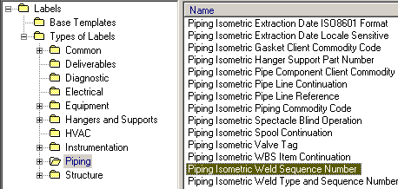
- Set the Drawing.Welds.ShowWeldNumbers option to True
- Save settings to catalog and exit
- FYI weld identifiers with spaces are not supported in the label
- Update iso of 1002-P and review the weld numbers on the drawing
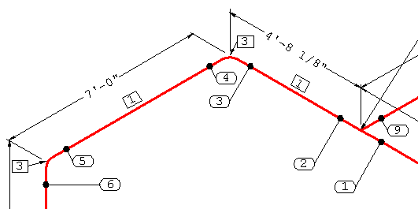
Implementing a custom Shaw weld number label
- Edit Options for style ShawIso_D
- Expand to Drawing.Welds.WeldNumberLabel
- Click the ellipsis button in the field to display the Catalog Labels dialog box and select label ShawTrainingWeldID located under the Piping Isometric folder for catalog labels (contact CAE if label is missing)
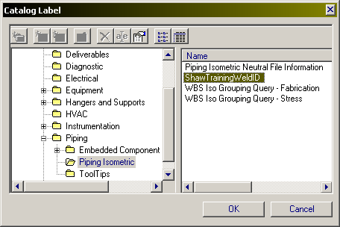
- Verify that Drawing.Welds.ShowWeldNumbers option is set to True
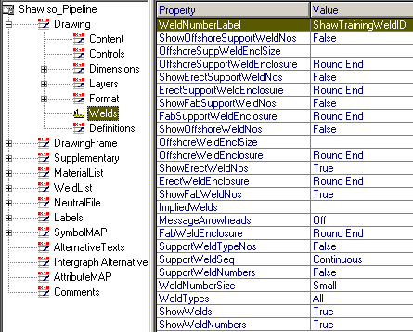
- Save settings to catalog and exit
- Update iso of 1002-P and review the weld numbers on the drawing
- The weld numbers should display a different format that makes them unique across the whole plant. In this case the pipeline name is suffixed with the weld number to form the weld number
